# Apply filters to SQL queries

## Project description

Acomplish requesting data from the database and receiving vital information such as time of login, hour, date, country etc.

## Retrieve after hours failed login attempts

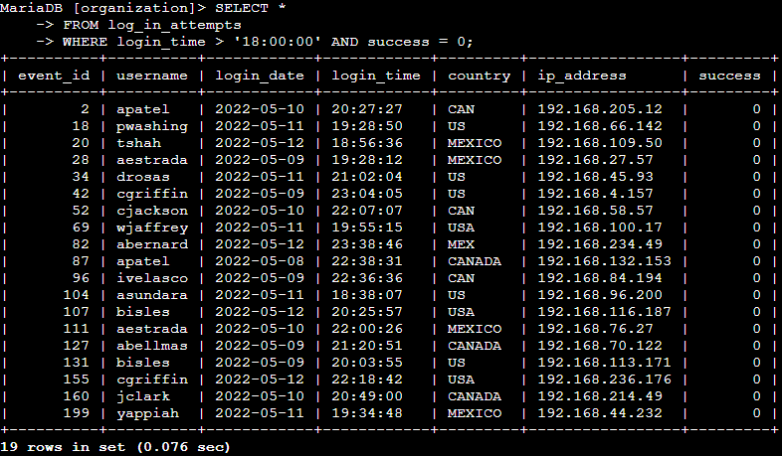

Retrieve login attempts on specific dates

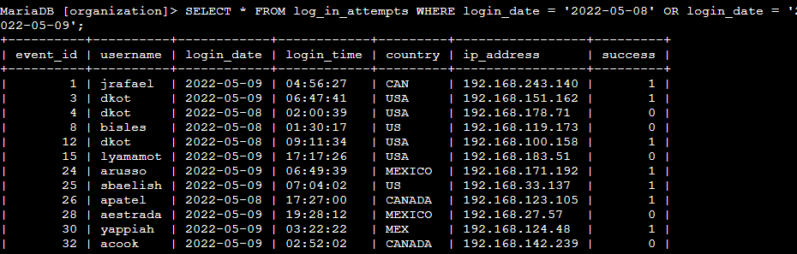

## Retrieve login attempts outside of Mexico

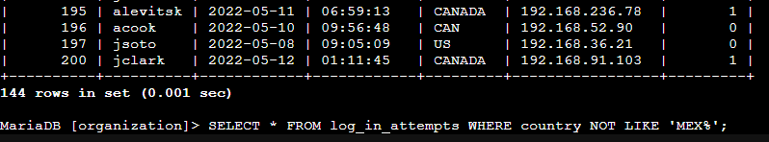

## Retrieve employees in Marketing

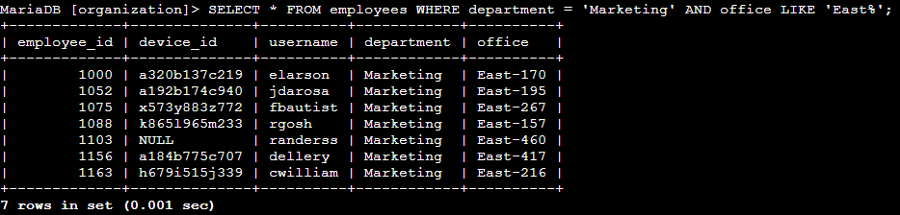

## Retrieve employees in Finance or Sales

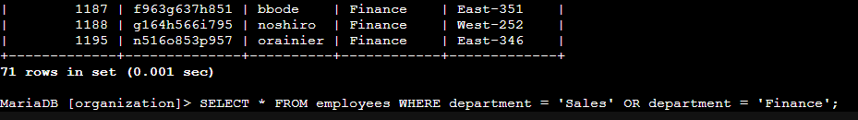

## Retrieve all employees not in IT

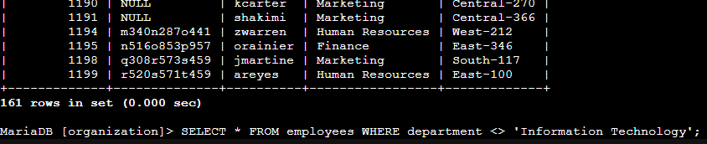

## Summary

In summary, this test is applied in order to test skills in regards of navigating the SQL database and retrieving data necessary in order to gather information on possible issues occurred security wise.